Answer the following questions.

1. Consider the following Dilbert cartoon? Would it be possible for a PRNG to spit out 6 NINEs in a row?

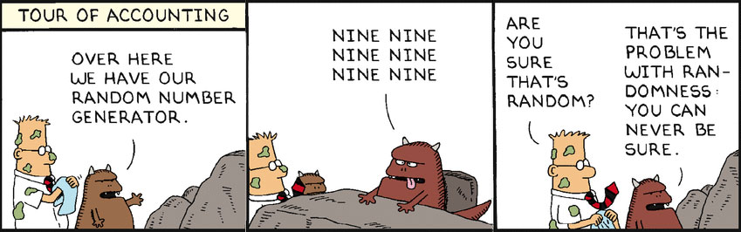

**Answer**

|  |
| --- |
| **Yes, it is completely possible but extremely unlikely for it to happen.** |

2. Are slot machines fair? Why or why not?

**Answer**

|  |
| --- |
| **No, they are allowed to be swayed to the casino's favor.** |

3. Is it possible to devise a method that would allow you to win consistently on a slot machine?

**Answer**

|  |
| --- |
| **Not really since the machines are still random even if they are not completely random.** |